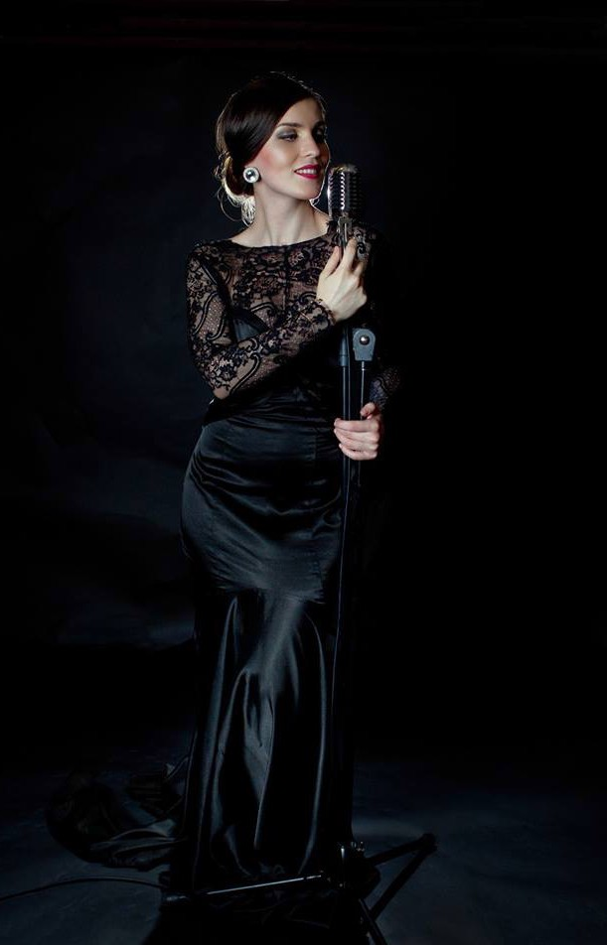

Oana Muresan j a z z v o c a l i s t

Oana Muresan
b i o g r a p h y

Oana’s passion for music started at a very early age , and started her formal music education at the age of seven. She studied the Piano , and at a later age received Classical Voice Training , sparking a
life long passion for Opera.
At school she received great merit , winning various Piano and Operatic Singing Competitions.



Taipa Village Macau
After School she got admitted to The Conservatory of Music , ‘Gheorge Dima’ in Cluj Napoca Romania , to study Piano and Opera.
It was there that her passion for Jazz started , and so began her training in Jazz and Pop Vocal Studies.
At the end of her studies, Oana received First Prize for Best Jazz Vocalist at the Sibu Jazz Festival in Romania. This sparked a series of concerts with national and international musicians ,
Bigbands and Orchestras.

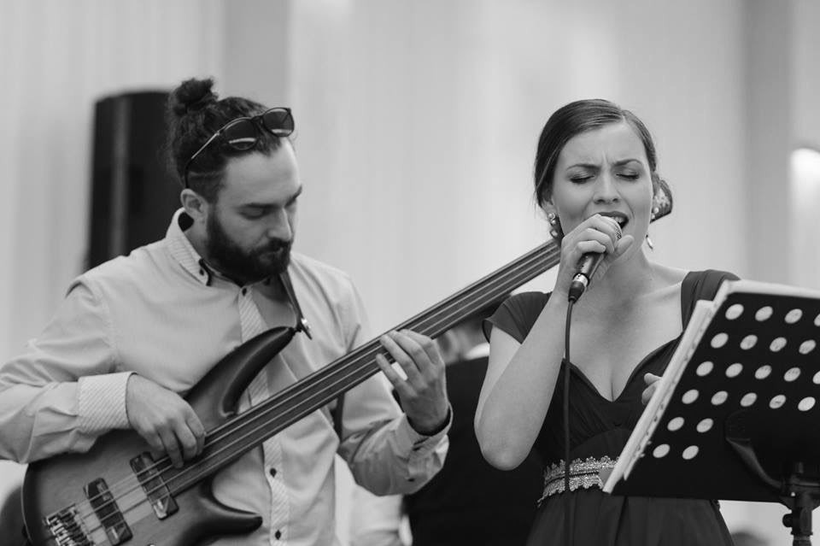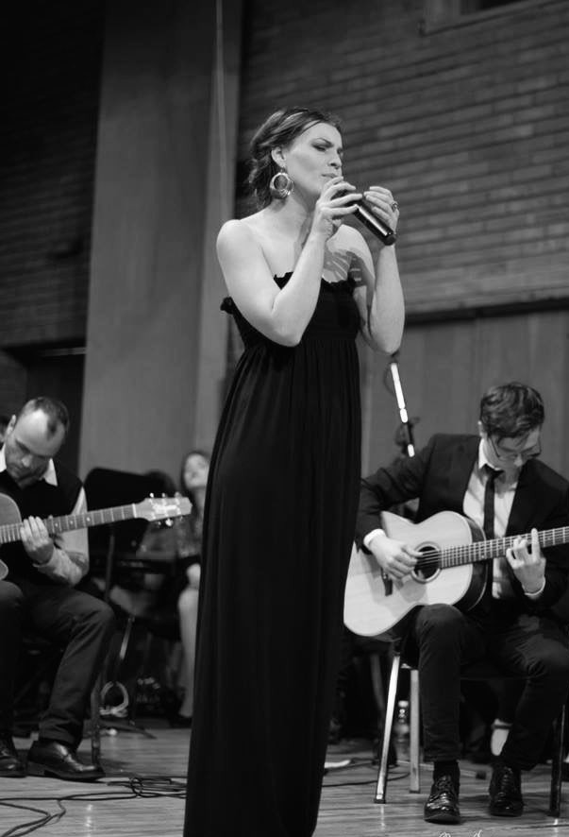Gheorge Dhima Conservatory

Hotel Plaza Cluj

In 2014 Oana started her International singing
career at the ‘Venetian’ Sands in Macau China. There she entertained guests from all over the world with her beautiful operatic voice, wearing spectacular costumes and gowns .
She also showed oﬀ her talent as a Pianist at the
Apex Conrad VIP Casino Piano Bar and at the

The Four Seasons Hotel.

During the time Oana worked at the SANDS
Casino Resorts , she had the opportunity to work with a Jazz Quartet who performed at various SANDS venues all over Macau.
She also performed for many corporate and private functions either singing Jazz , Pop , Opera or playing the Piano.

In 2016 she took up a position as a Jazz Vocalist at The Ritz Carlton , at GALAXY Casino Macau.
For a year she performed six nights a week with a South African Pianist and a Canadian Saxophonist, performing a large selection of Jazz Standards. There they entertained guests with a repertoire of classic vocal jazz ranging from Irving Berlin , George Gershwin , Cole Porter to Duke Ellington.
Oana also brought tribute to many Ladies of Jazz , like Billy Holiday, Ella Fitzgerald , Peggy Lee , Dorris Day and Dee Dee Bridgewater.

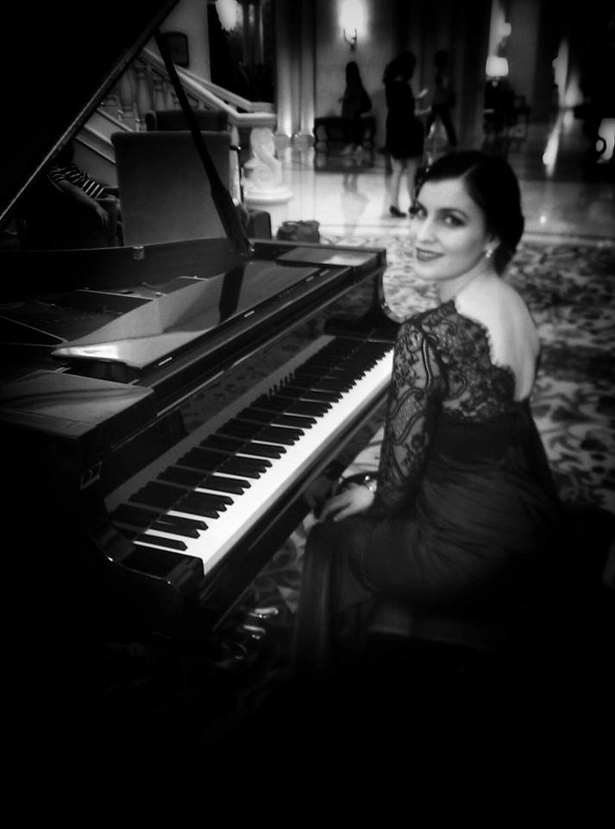

Four Seasons Macau China
She also included a large repertoire of World Music and Brazilian Jazz , singing in Portuguese , Spanish and in French. Thus catering to a large group of guests visiting from South America and Portugal.

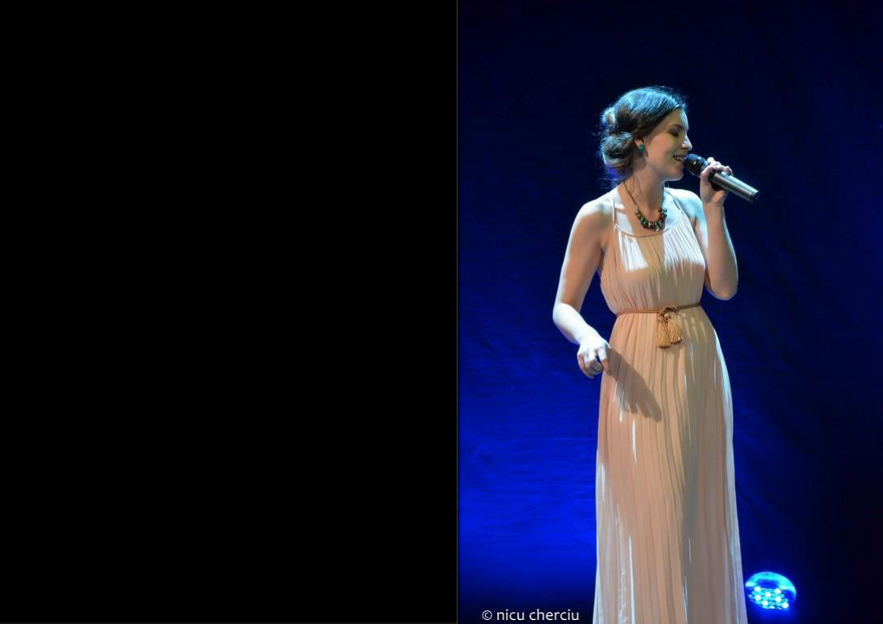Together with the Pianist at the Ritz Carlton , Oana also had loads of creative fun , arranging existing Pop songs into a Jazz style , to the immense delight of audiences.

Oana’s great versatility and elegant style also shines through her great repertoire of Pop , Soul , R&B and Blues. Thus making her a sought after performer for any Venue , Corporate Event and Private Function.

Opera House Bucharest



Bucharest Romania

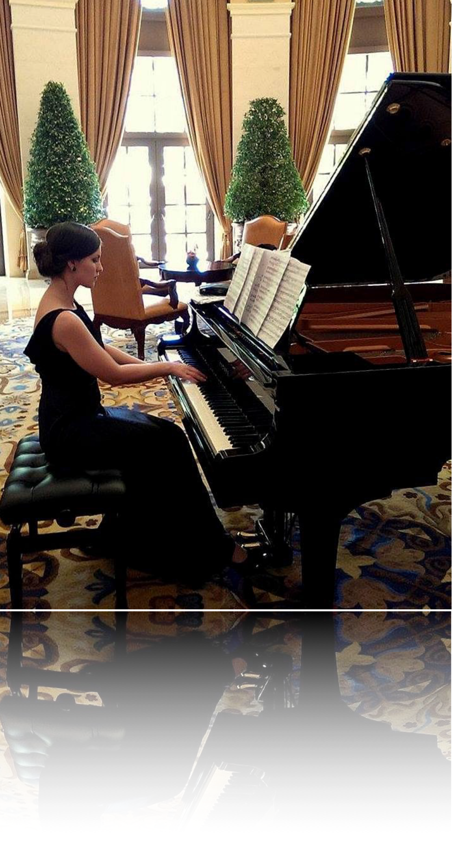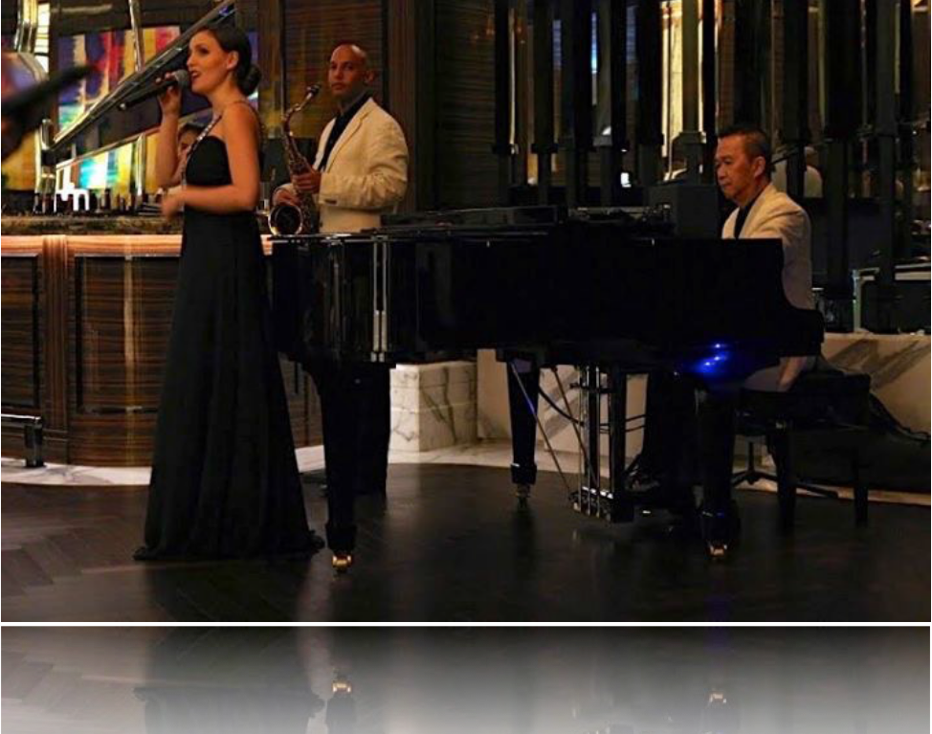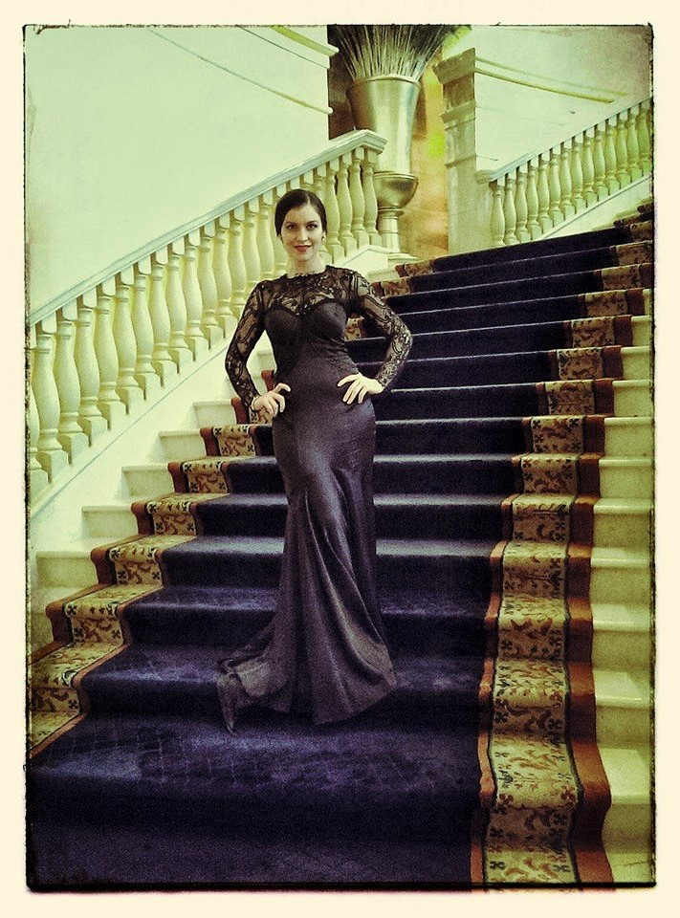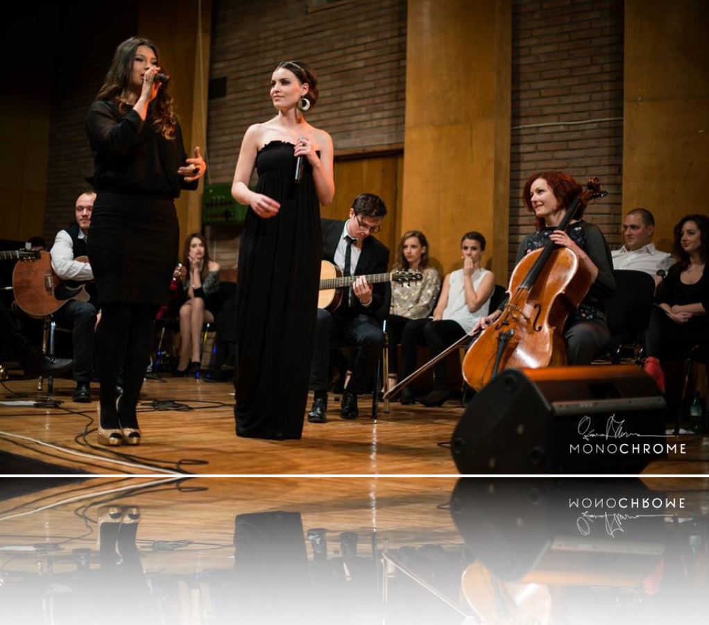The Venetian Macau

George Dhima Conservatory

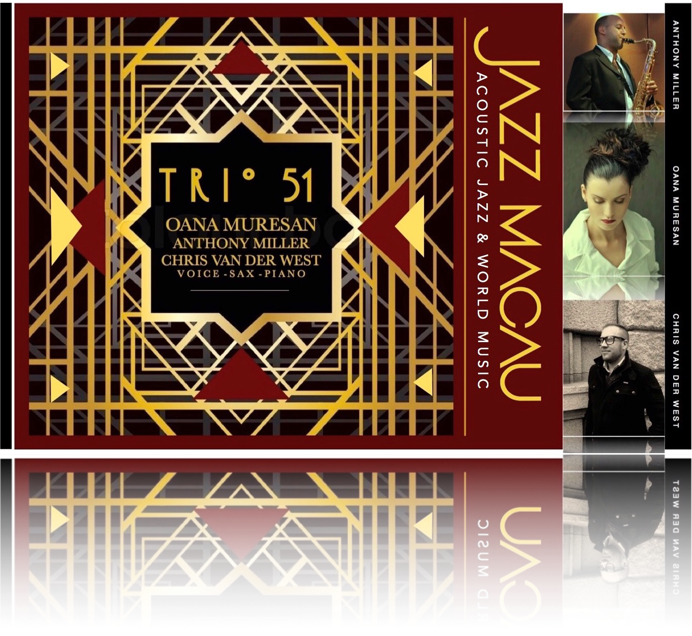The Four Seasons Macau

The Ritz Carlton Macau

